**Getting Images from the Server**

1. First you will have to fetch image paths from the server. Endpoint for the fetch API is: **“/getImagePaths”**. If the status code is 200 you will get image paths in this form:

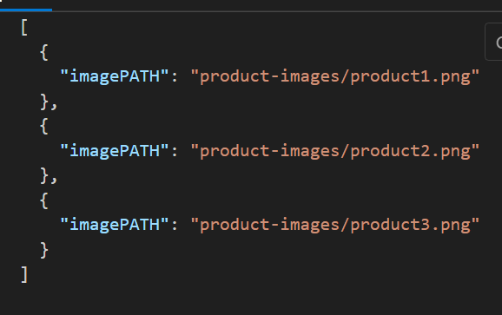

1. After extracting the imagePATH you can access the image by writing this url: `http://192.168.18.193/${desired image path}`.